**5.1 Polynomial Functions**

Objectives: To classify Polynomials.

To Use the of Graph Polynomial Functions to Describe End Behavior.

Identifying Polynomials:

**Polynomial:** **f(x) = anxn + an-1xn-1 + … + a1x + a0**, where an ≠ 0, exponents are all whole numbers, and coefficients are all real numbers

* *Leading Coefficient* = an
* *Constant Term* = a0
* *Degree* = n
* **Standard Form**: when terms are written in descending order of exponents from left to right

*Example: f(x) = 5x4 – 3x3 + 7x2 + x – 10*

**Common Types of Polynomial Functions**

|  |  |  |
| --- | --- | --- |
| **Degree** | **Type** | **Standard Form** |
| 0 | *Constant* | f(x) = a0 |
| 1 | *Linear* | f(x) = a1x + a0 |
| 2 | *Quadratic* | f(x) = a2x2 + a1x + a0 |
| 3 | *Cubic* | f(x) = a3x3 + a2x2 + a1x + a0 |
| 4 | *Quartic* | f(x) = a4x4 + a3x3 + a2x2 + a1x + a0 |

Examples:

*Decide whether the function is a polynomial function. If it is, write the function in standard form and state the degree, type and leading coefficient.*

f(x) = 12 – 5x f(x) = x – 3x-2 – 2x3

f(x) = 36x2 – x3 + x4 f(x) = x + π

**End Behavior**: the behavior of the graph as x approaches positive and negative infinities

x → + ∞ is read as “x approaches positive infinity”

f(x) = x f(x) = -x

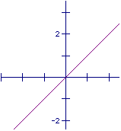 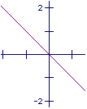

f(x) → - ∞ as x → - ∞ f(x) → + ∞ as x → - ∞

f(x) → + ∞ as x → + ∞ f(x) → - ∞ as x → + ∞

f(x) = x2 f(x) = -x2

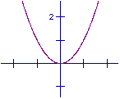 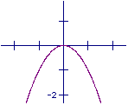

f(x) → + ∞ as x → - ∞ f(x) → + ∞ as x → - ∞

f(x) → + ∞ as x → + ∞ f(x) → - ∞ as x → + ∞

*Examples:* *From the graph of the function, complete the statement:*

*f(x) → ______ as x → - ∞, and f(x) → ______ as x → + ∞*

f(x) = x3 f(x) = x4 f(x) = x5 f(x) = x6

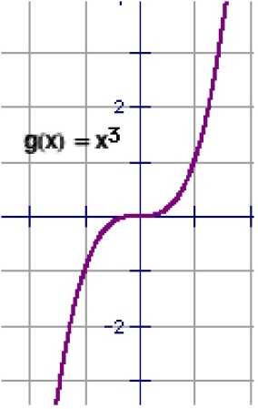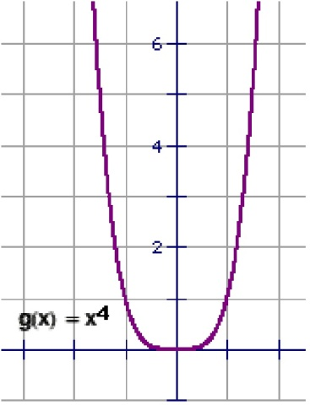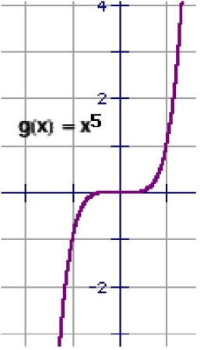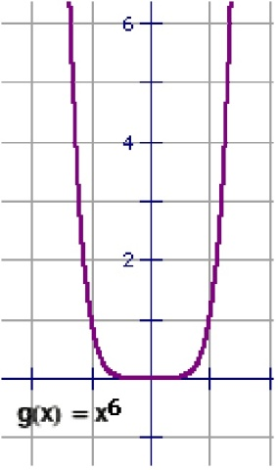

f(x) = -x3 f(x) = -x4 f(x) = -x5 f(x) = -x6

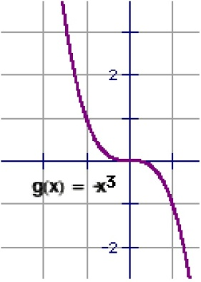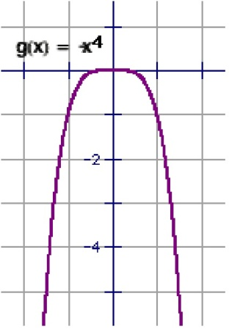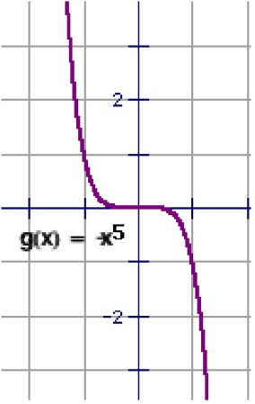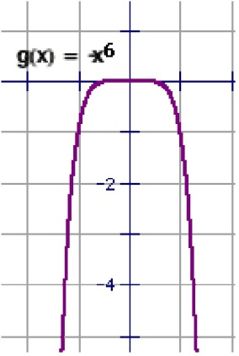

**End Behavior for Polynomial Functions**;

|  |  |  |  |
| --- | --- | --- | --- |
| **LC** | **n** | **x → - ∞** | **x → + ∞** |
| + | Even | + | + |
| + | Odd | - | + |
| - | Even | - | - |
| - | Odd | + | - |

*Examples:*

*Describe the end behavior of the following functions:*

***Note: Use Graphing Calculator to point out end behavior, local max/min and turning points.***

a) f(x) = x5 + 2x2 - x + 4 b) f(x) = -x3 + 3x2 + 6x – 2

c) f(x) = 2x4 + 2x – 1 d) f(x) = -x3 + 2

e) f(x) = 2 + x2 – x4 f) f(x) = 4 – x4

HMWK: page 285 #1-7, 9-27 (odd), 39, 43, 47